Lab 6

Make sure that you understand the difference between XML and JSON format. *Check out this link [http://json.org/example.html](https://www.google.com/url?q=http://json.org/example.html&sa=D&ust=1490246024237000&usg=AFQjCNEtAkLTc6Ft3GYab1cun8bsMrRQag). Run the following JavaScript in the console or [http://eloquentjavascript.net/code](https://www.google.com/url?q=http://eloquentjavascript.net/code&sa=D&ust=1490246024238000&usg=AFQjCNE4dy7z7Xe9FRNkMrS9doKEgqTvFA) :

var apiRequest = new XMLHttpRequest();

apiRequest.open("GET", "https://maps.googleapis.com/maps/api/geocode/json?address=The+White+House", false);

apiRequest.send();

console.log(apiRequest.responseText)

1. What is the format of the information in the responseText property (XML or JSON)?

**Here is the screenshot of the console after running the code above. As you can see, results is in JSON format**

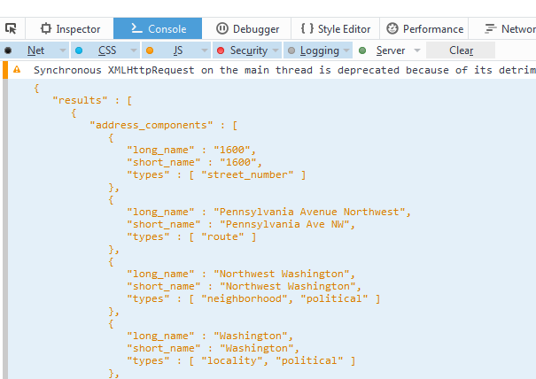

1. What HTTP request method was used in the above request?

**From the line of code we see that GET request method is being used**

apiRequest.open("**GET**", "https://maps.googleapis.com/maps/api/geocode/json?address=The+White+House", **false**);

1. How would you convert the string apiRequest.responseText to a JavaScript object? Please write and run the code. Store the object in a variable named myObj. Provide a screenshot.

**We convert it using JSON.parse() function. Here is the code**

**var** apiRequest = **new** XMLHttpRequest();

apiRequest.open("GET", "https://maps.googleapis.com/maps/api/geocode/json?address=The+White+House", **false**);

apiRequest.send();

**var** myObj=JSON.parse(apiRequest.responseText);

console.log(myObj);

**Here is the screenshot. As you can see, object contains one array and one string variable**

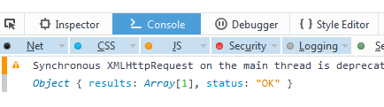

1. Add this line to the code console.log(myObj.results[0]) Run the code. Click the ellipses or triangle to view the contents of the array. What are five property names? What is the value stored in the formatted_address property?

**Here is the contents of results array.**

Object {

address_components: Array[**7**],

formatted_address: "1600 Pennsylvania Ave NW, Washingto…",

geometry: Object,

place_id: "ChIJ37HL3ry3t4kRv3YLbdhpWXE",

types: Array[**2**] }

**As you can see thee 5 properties: address_components, formatted_address, geometry, place_id, types.**

**The value of formatted_address property is "1600 Pennsylvania Ave NW, Washington, DC 20500, USA". But it doesn’t show address fully as you can see below. But if you click Object in the first line it opens the contents of the object. There you can see values of sub properties as well.**

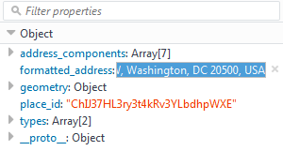

1. This is how you would access the formatted_address property: console.log(myObj.results[0].formatted_address) How would you access the place_id property? Write and run the code. Provide a screenshot.

**We access the place_id property value using the following code**

console.log(myObj.results[**0**].place_id);

**The full JavaScript code is**

**var** apiRequest = **new** XMLHttpRequest();

apiRequest.open("GET", "https://maps.googleapis.com/maps/api/geocode/json?address=The+White+House", **false**);

apiRequest.send();

**var** myObj=JSON.parse(apiRequest.responseText);

console.log(myObj.results[**0**].formatted_address);

console.log(myObj.results[**0**].place_id);

1. Use the google API explorer to format a request URL to translate a word from english to the language of your choice: [https://developers.google.com/apis-explorer/#search/translate/m/translate/v2/language.translations.list](https://www.google.com/url?q=https://developers.google.com/apis-explorer/%23search/translate/m/translate/v2/language.translations.list&sa=D&ust=1490246024252000&usg=AFQjCNGKFLqdyi-SkZMIfdcRWSi3S5iR1A)  In the target box you should place the target language’s code a list is here: [https://sites.google.com/site/tomihasa/google-language-codes](https://www.google.com/url?q=https://sites.google.com/site/tomihasa/google-language-codes&sa=D&ust=1490246024253000&usg=AFQjCNE3cpxHPsfvZZlex80Jr4bkScHaOg) You should place the word to be translated into the q box. Scroll down to find the URL. Note you would need to obtain a key to the URL string. Paste your URL here. What is the response of the request at the bottom of the page. Paste the JSON text here. What was the translated word?

**Here is my url. Since it asked credit card information I didn’t create a key, but tested it demo version.**

https://www.googleapis.com/language/translate/v2?q=I+want+to+learn+Spanish&target=es&cid=splan&format=html&source=en&key={YOUR_API_KEY}

**Here is JSON text of the translation. I translated from English to Spanish. Text to be translated was “I want to learn Spanish”. As you can see from the JSON text below, it translates to “quiero aprender español”**

{

"data": {

"translations": [

{

"translatedText": "quiero aprender español"

}

]

}

}

1. How much does it cost to use the translate API? [https://cloud.google.com/translate/pricing](https://www.google.com/url?q=https://cloud.google.com/translate/pricing&sa=D&ust=1490246024255000&usg=AFQjCNHtkOW-W6ivAiyxEuzT6k5COEGRsA) ? Do you think this is expensive?

**It costs $20 to translate per million characters including white spaces. Why should I pay for white space? Anyway, if it were human translation it would be reasonable price, but for robot translation, it is expensive.**

1. There is a free work around. You should format the following URL:   https://translate.googleapis.com/translate_a/single?client=gtx&sl="   
              + sourceLang + "&tl=" + targetLang + "&dt=t&q=" + sourceText

For instance, if I want to translate the word science from english to turkish, I would use the following URL where ‘en’ is my source language, ‘tr’ is my target language, and ‘science’ is the word I want to translate.

"[https://translate.googleapis.com/translate_a/single?client=gtx&sl=en&tl=tr&dt=t&q=science](https://www.google.com/url?q=https://translate.googleapis.com/translate_a/single?client%3Dgtx%26sl%3Den%26tl%3Dtr%26dt%3Dt%26q%3Dscience&sa=D&ust=1490246024258000&usg=AFQjCNFx0ObbUf1zeYapS0bbEnO4x3eTfA)"

Use the code at the top of the page to make an API call. Use your formatted URL instead of the google maps URL. Provide a screenshot. (Note that some languages you need to URI encode the text due to presence of special characters. If you have issues, just use the sample URL above.)

**I have used the workaround URL to translate and API request code above to make JavaScript translate the sentence “Have you been to Paris” to French. Here is the code**

**var** apiRequest = **new** XMLHttpRequest();

apiRequest.open("GET", "https://translate.googleapis.com/translate_a/single?client=gtx&sl=en&tl=fr&dt=t&q=Have+you+been+to+Paris", **false**);

apiRequest.send();

console.log(apiRequest.responseText)

**Here is the screenshot of console**

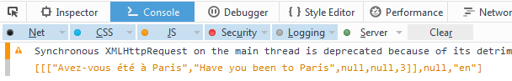

**I don’t how it reads in French but it seems it translated it for free. It is amazing.**